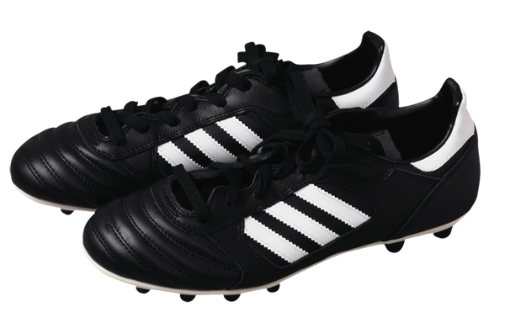 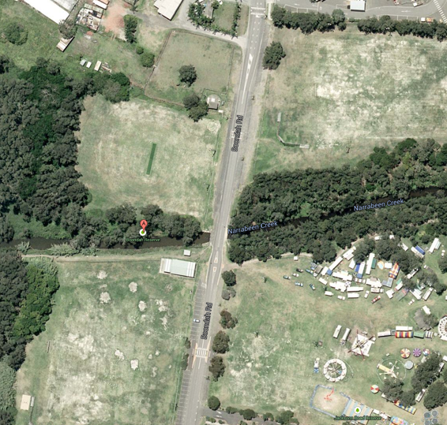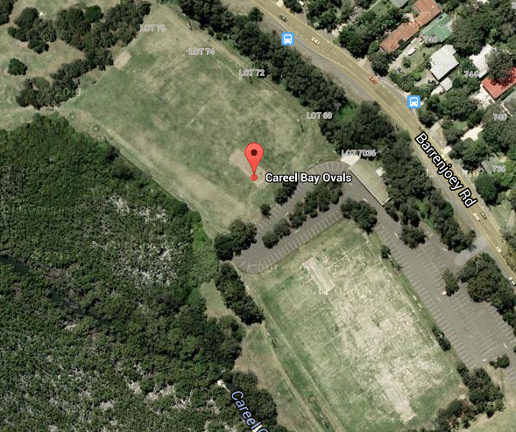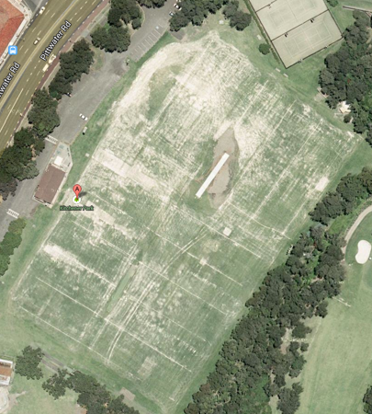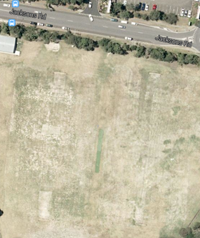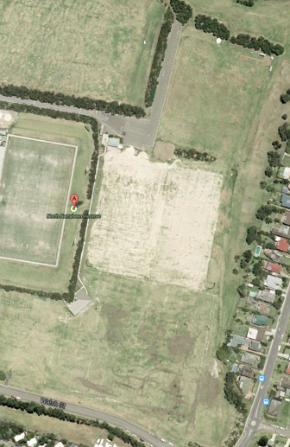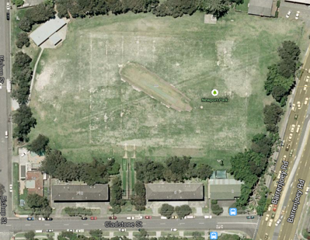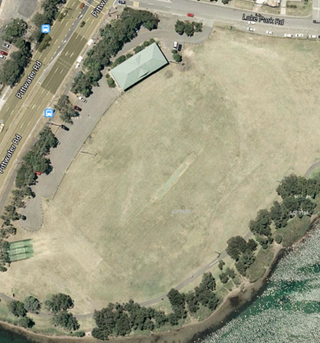

## **JUNIOR & SENIOR**

## **BOYS and GIRLS**-

**Football**

## (Kitchener, Careel Bay, Boondah, NNPS) **JUNIOR & SENIOR GIRLS** –

## **Netball**

## (Boondah Courts) **JUNIOR & SENIOR BOYS** –

## **Rugby League**

## (Newport, Narrabeen Reserve 3 & 4, Lake Park)

**1. AVALON 2. COLLAROY PLATEAU 3. BILGOLA PLATEAU 4. NARRABEEN LAKES 5. ELANORA HEIGHTS 6. NARRABEEN NORTH 7. WHEELER HEIGHTS 8. MONA VALE 9. NEWPORT**



Pittwater PSSA Winter Draw

|  |  |  |  |  |  |  |
| --- | --- | --- | --- | --- | --- | --- |
| Term 2  Week 3  8 May | Netball  Football  Rugby League | **2v7** | **1v4** | **3v8** | **5v6** | **9 Bye** |
| Boondah  Boondah  Lake Park | Boondah  Careel Bay  Narrabeen 3 | Boondah  Kitchener  Newport | Boondah  NNPS  Narrabeen 4 |  |
| Week 4  15 May | Netball  Football  Rugby League | **9v1** | **2v3** | **8v4** | **6v7** | **5 Bye** |
| Boondah  Careel Bay  Newport | Boondah  Boondah  Lake Park | Boondah  Kitchener  Narrabeen 3 | Boondah  NNPS  Narrabeen 4 |  |
| Week 5  22 May | Netball  Football  Rugby League | **2v1** | **3v9** | **5v8** | **6v4** | **7 Bye** |
| Boondah  Boondah  Narrabeen 3 | Boondah  Careel Bay  Newport | Boondah  Kitchener  Narrabeen 4 | Boondah  NNPS  Lake Park |  |
| Week 6  29 May | Netball  Football  Rugby League | **7v5** | **9v2** | **1v3** | **8v6** | **4 Bye** |
| Boondah  Boondah  Lake Park | Boondah  Kitchener  Newport | Boondah  Careel Bay  Narrabeen 3 | Boondah  NNPS  Narrabeen 4 |  |
| Week 7  5 June | Netball  Football  Rugby League | **7v4** | **9v5** | **6v1** | **8v2** | **3 Bye** |
| Boondah  Boondah  Lake Park | Boondah  NNPS  Narrabeen 3 | Boondah  Careel Bay  Newport | Boondah  Kitchener  Narrabeen 4 |  |
| **Week 8 12 June Combined Schools Gala Day** | | | | | | |
| Week 9  19 June | Netball  Football  Rugby League | **8v9** | **1v7** | **4v2** | **3v5** | **6 Bye** |
| Boondah  Kitchener  Narrabeen 3 | Boondah  NNPS  Narrabeen 4 | Boondah  Boondah  Lake Park | Boondah  Careel Bay  Newport |  |

|  |  |  |  |  |  |  |
| --- | --- | --- | --- | --- | --- | --- |
| **Term 3**  **Week 1**  **17 July** | Netball  Football  Rugby League | **4v5** | **1v8** | **6v3** | **7v9** | **2 Bye** |
| Boondah  NNPS  Lake Park | Boondah  Boondah  Narrabeen 3 | Boondah  Careel Bay  Narrabeen 4 | Boondah  Kitchener  Newport |  |
| Week 2  24 July | Netball  Football  Rugby League | **4v9** | **3v7** | **2v6** | **5v1** | **8 Bye** |
| Boondah  Kitchener  Lake Park | Boondah  NNPS  Newport | Boondah  Boondah  Narrabeen 3 | Boondah  Careel Bay  Narrabeen 4 |  |
| Week 3  **31 July** | Netball  Football  Rugby League | **5v2** | **4v3** | **9v6** | **7v8** | **1 Bye** |
| Boondah  Boondah  Lake Park | Boondah  NNPS  Narrabeen 4 | Boondah  Careel Bay  Newport | Boondah  Kitchener  Narrabeen 3 |  |
| **Week 4**  **7 August** | TBA- Wet weather make up games | | | | | |
| **Week 5**  **14 August** |
| **Week 6**  **21 August** |

First mentioned team is home team. Home team coach referees Senior game - Away coach referees Junior game.

Rugby League- Referee supplied. Grounds Manager is home team coach.

**Netball**

**Girls Football**

**Boys Football**

### Boondah Reserve Narrabeen- Netball & Football

Girls Football

Boys Football

### Careel Bay Oval Avalon- Football

Girls Football

Boys Football

### Kitchener Park Mona Vale- Football

Girls Football

Boys Football

### Narrabeen North PS- Football

### Narrabeen North Reserve- Rugby League

Golf Driving Range

Field 4

Field 3

### Newport Oval- Rugby League

### Lake Park Narrabeen- Rugby League